Open Up the Textbook (OUT): The Creation of the State of Israel
Enlarge Complicate Contest Vivify

In this OUT analysis, 10th Grade World Geography students will study The Creation of the State Of Israel in order to better understand the cultural and historical context for its creation. This OUT analysis provides students with documents that are meant to deliberately enlarge and complicate the textbook account.

Source A: The Textbook – “Creating the State of Israel.” (pgs. 512-513) World Geography: McDougall Littell (2007).

At the end of World War II, thousands of Jewish survivors of the Holocaust wanted to settle in Palestine. Palestine was considered the Jewish homeland. World opinion supported the establishment of a Jewish nation-state. Britain eventually referred the question of a Jewish homeland to the United Nations. In 1947, the United Nations developed a plan to divide Palestine into two states—one for Arabs and one for Jews.

Arabs in the region did not agree with division. However, the nation of Israel was established on May 14, 1948. Immediately, the surrounding Arab nations of Egypt, Syria, Lebanon, Jordan, Iraq, Saudi Arabia and Yemen invaded Israel to prevent the establishment of the state. Jewish troops fought back. By the 1950s, Israel was a firmly established nation. The 1948 war was the beginning of hostilities that continue to this day.

Source A: Questions for Consideration

- What reasons are given for the creation of the State of Israel in the textbook account?

- The text claims that “Palestine was considered a Jewish homeland.” Is there evidence in the text to support this claim?

- According to the text, “World opinion supported the establishment of a Jewish nation-state.” How does the second paragraph complicate this idea?

- How does the definition of “Arab” provided in Footnote #1, complicate and add to your understanding of the creation of a Jewish homeland?

Source B: The Torah (Old Testament): Book of Genesis 17:1-8 (around 1800 BCE)

The Covenant of Circumcision
17 When Abram was ninety-nine years old, the Lord appeared to him and said, “I am God Almighty; walk before me faithfully and be blameless. ² Then I will make my covenant between me and you and will greatly increase your numbers.”

³ Abram fell facedown, and God said to him, ⁴ “As for me, this is my covenant with you: You will be the father of many nations. ⁵ No longer will you be called Abram; your name will be Abraham, for I have made you a father of many nations. ⁶ I will make you very fruitful; I will make nations of you, and kings will come from you. ⁷ I will establish my covenant as an everlasting covenant between me and you and your descendants after you for the generations to come, to be your God and the God of your descendants after you. ⁸ The whole land of Canaan, where you now reside as a foreigner, I will give as an everlasting possession to you and your descendants after you; and I will be their God.”

Source B: Questions for Consideration

- What type of source is this and when was it written?

- Based on the source and the phrase, “your descendants after you and for the generations to come” what can you infer about the audience of this text?

- The word covenant describes a promise, pact, or agreement. What language (words, phrases, images) does the author use to describe the covenant to his audience?

- How does text enlarge your understanding of a justification for A Jewish Homeland?

Source C: Contemporary political map of the Middle East with an overlay of Biblical Israel (The Land of Canaan).
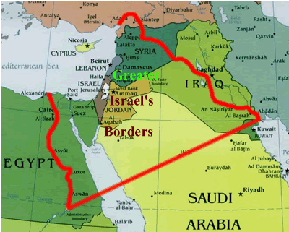

Source C: Questions for Consideration

- This map serves two purposes. Describe each one.

- How many modern day nations are within the boundaries of “Greater Israel’s Borders?” What are they?

- Based on the evidence you found in sources A-C, what word would best describe the creation of the boundaries of state of Israel: reasoned, political, arbitrary, or careful. Explain.

Source D: Encyclopedia Britannica Online – Zionism Entry (January, 2015)

Zionism is the Jewish nationalist movement that has had as its goal the creation and support of a Jewish national state in Palestine, the ancient homeland of the Jews. Though Zionism originated in eastern and central Europe in the latter part of the 19th century, it is in many ways a continuation of the ancient nationalist attachment of the Jews and of the Jewish religion to the historical region of Palestine, where one of the hills of ancient Jerusalem was called Zion.

In the 16th and 17th centuries a number of “messiahs” came forward trying to persuade Jews to “return” to Palestine. The Haskala (“Enlightenment”) movement of the late 18th century, however, urged Jews to assimilate into Western secular culture.

A political turn was given to Zionism by Theodor Herzl, an Austrian journalist, who regarded assimilation as most desirable but, in view of anti-Semitism, impossible to realize. Thus, he argued, if Jews were forced by external pressure to form a nation, they could lead a normal existence only through concentration in one territory. In 1897 Herzl convened the first Zionist Congress at Basel, Switzerland, which drew up the Basel program of the movement, stating “Zionism strives to create for the Jewish people a home in Palestine secured by public law.”

Source D: Questions for Consideration

- What do you learn about Zionism from the first paragraph of the text?
- Using evidence from the text, write a definition for the word assimilate. How does the ideology of Zionism differ from the idea of assimilation for the Jewish people?

- Today, Theodor Herzl is known as the “Father of Zionism.” What reasoning did he provide for the need for “a home in Palestine secured by public law”?

- How does this basic description of Zionism enlarge/and or/complicate your understanding of a Jewish Homeland?

Source E: The Balfour Declaration: James Balfour, November 2, 1917

Foreign Office (of Great Britain)
November 2nd, 1917
Dear Lord Rothschild,
I have much pleasure in conveying to you, on behalf of His Majesty's Government (Great Britain), the following declaration of sympathy with Jewish Zionist aspirations which has been submitted to, and approved by, the Cabinet.
"His Majesty's Government view with favour the establishment in Palestine of a national home for the Jewish people, and will use their best endeavours to facilitate the achievement of this object, it being clearly understood that nothing shall be done which may prejudice the civil and religious rights of existing non-Jewish communities in Palestine, or the rights and political status enjoyed by Jews in any other country."
I should be grateful if you would bring this declaration to the knowledge of the Zionist Federation.
Yours sincerely,
Arthur James Balfour

Source E: Questions for Consideration
- What do you learn about this document from the first four lines of text? Why is the date of this document important?

- Why was this written?

- What stipulation or condition does Balfour give for a Zionist home in Palestine in the second paragraph?

- How does this document enlarge your understanding of a Jewish Homeland?

Source F: The White Paper of 1939: Issued by the British Government (excerpted)

His Majesty's Government believe that the framers of the Mandate in which the Balfour Declaration was embodied could not have intended that Palestine should be converted into a Jewish State against the will of the Arab population of the country... His Majesty's Government therefore now declare unequivocally that it is not part of their policy that Palestine should become a Jewish State. They would indeed regard it as contrary to their obligations to the Arabs under the Mandate, as well as to the assurances which have been given to the Arab people in the past, that the Arab population of Palestine should be made the subjects of a Jewish State against their will.

Source F: Questions for Consideration
- What kind of document is this? What is its purpose and how is it different from Source E?

- In what ways does this document compare to the Balfour Declaration (Source E)?

- With your understanding of the text and the word “mandate,” What inferences can you make about role of Great Britain in Palestine from 1917-1939?

Source G: Palestine: Land Ownership By Sub-Districts (1945)
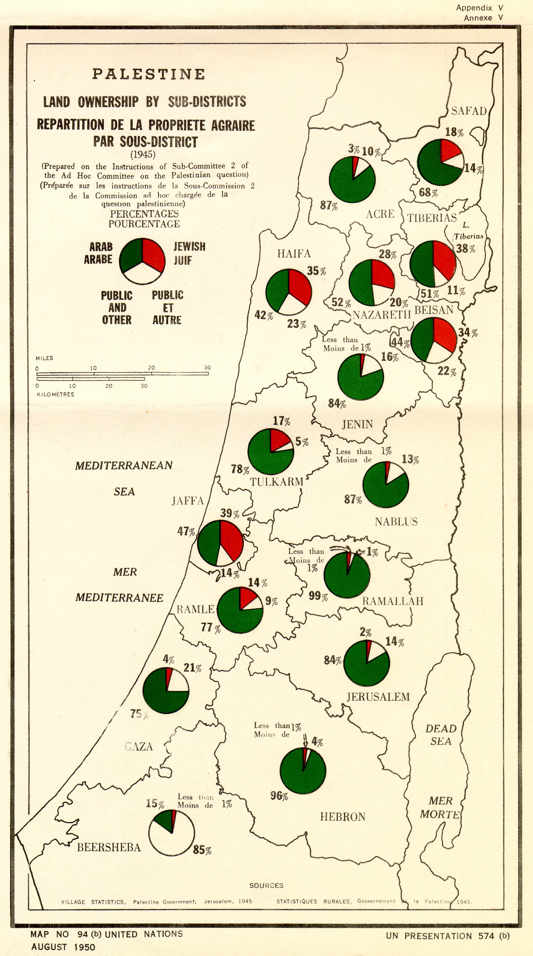

Source G: Questions for Consideration
- What do you learn from the title and key for this map. List as many details as you discover.
- What groups are represented within each pie-graph?
- The data was collected in 1945 but the map was published in 1950, what can you infer about the population of this region when the State of Israel was created in 1948?

Source H: Newspapers From the first half of the 20th Century Era Newspapers 1905- 1946
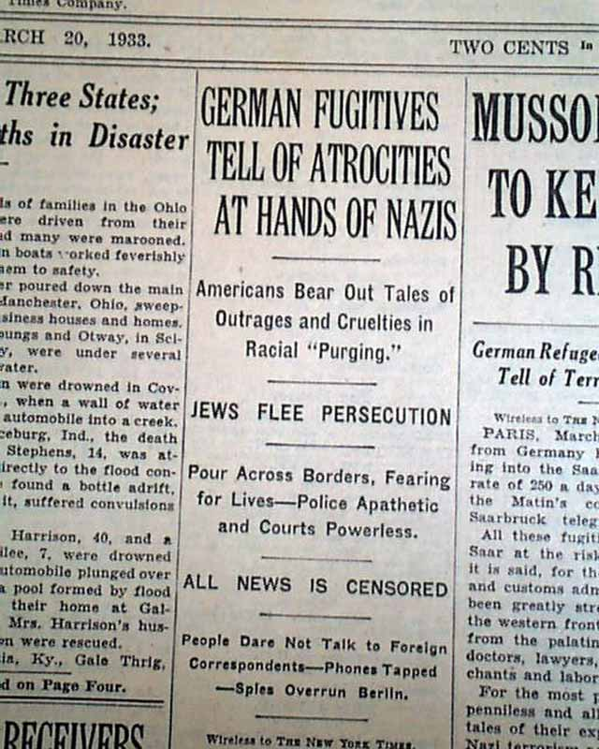
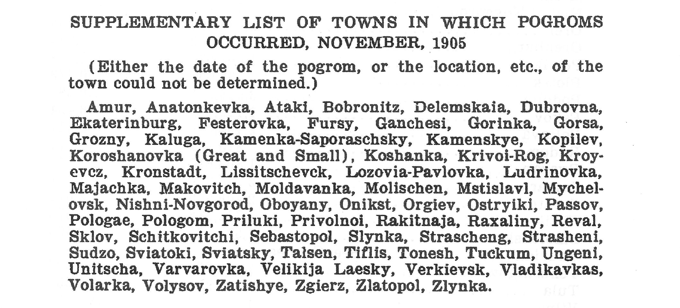

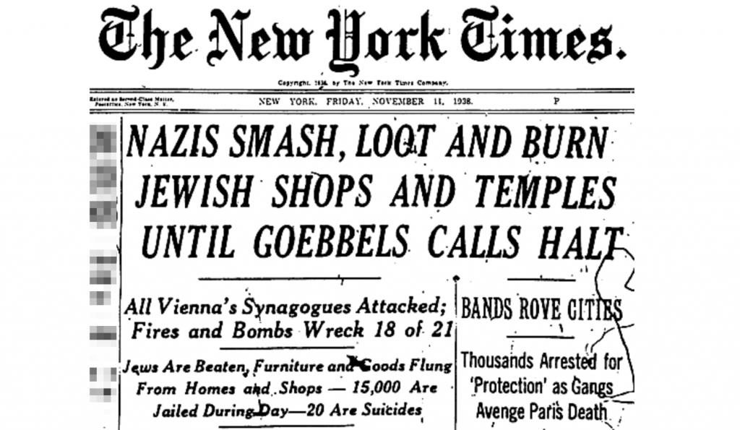
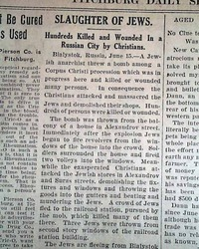

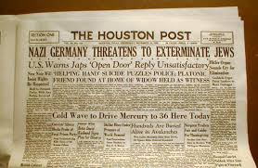
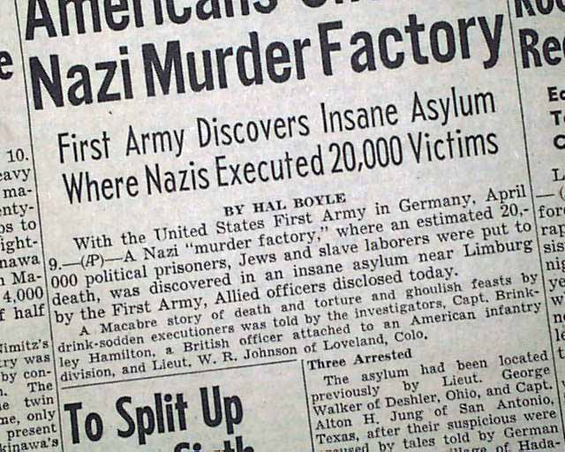

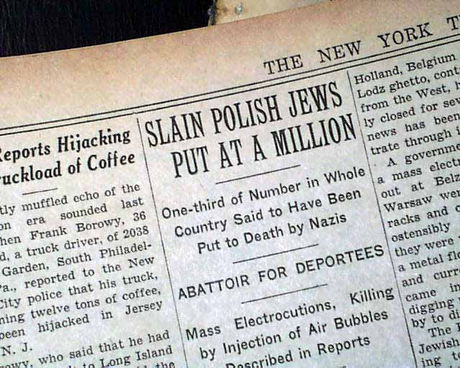

Source H: Questions for Consideration:

- What type of documents are these? Who is the intended audience? How do you know this?

- What types of actions are being taken against Jewish people in these documents?

- When is the first report of anti-Semitic action? How many years before the holocaust was this?

- What sources in this OUT show responses to the problems reported in these headlines? Cite the source and the evidence.

- Write a statement that generalizes the treatment of Jewish people in Europe in the first half of the 20th Century?

- How does this expand your understanding of the need for the creation of a Jewish State?

Source I: United Nations Resolution 181: On the Creation of the State of Israel (1948)

Region | Members in UNGA181 Vote | UNGA181  For | UNGA181  Against | UNGA181 Abstained
African | 4 | 2- Liberia, South Africa | 1- Egypt | 1
Asia- Pacific | 11 | 1- Philippines | 9- Afghanistan, India, Iran, Iraq, Lebanon, Pakistan, Saudi Arabia, Syria, Yemen | 1
Eastern European | 6 | 5- Byelorussian, Czechoslovakia, Poland, Ukrainian, Soviet Union | 0 | 1
Latin America & Caribbean | 20 | 13- Bolivia, Brasil, Costa Rica, Dominican Republic, Ecuador, Guatemala, Haití, Nicaragua, Panamá, Paraguay, Perú, Uruguay, Venezuela | 1- Cuba | 6
Western European & Others | 15 | 12- Belgium, Denmark, France, Iceland, Luxembourg, Netherlands, Norway, Sweden, Australia, New Zealand, Canada, U.S. | 2- Greece, Turkey | 1
Total UN Members | 56 | 33 | 13 | 10
Note: UNGA- United Nations General Assembly

Source I: Questions for Consideration

- What kind of document is this? Describe the information it is communicating to the reader.

- The region listed as Asia Pacific is poorly name. Explain why and create a better name for the region.

- Which regions supported Israeli statehood? Which regions opposed it?

- Which countries that opposed Israeli statehood are represented in Source C?

- How does this document expand your understanding of the creation of Israel?
Source J: Chart: Map: Palestinian Loss of Land 1947-Present
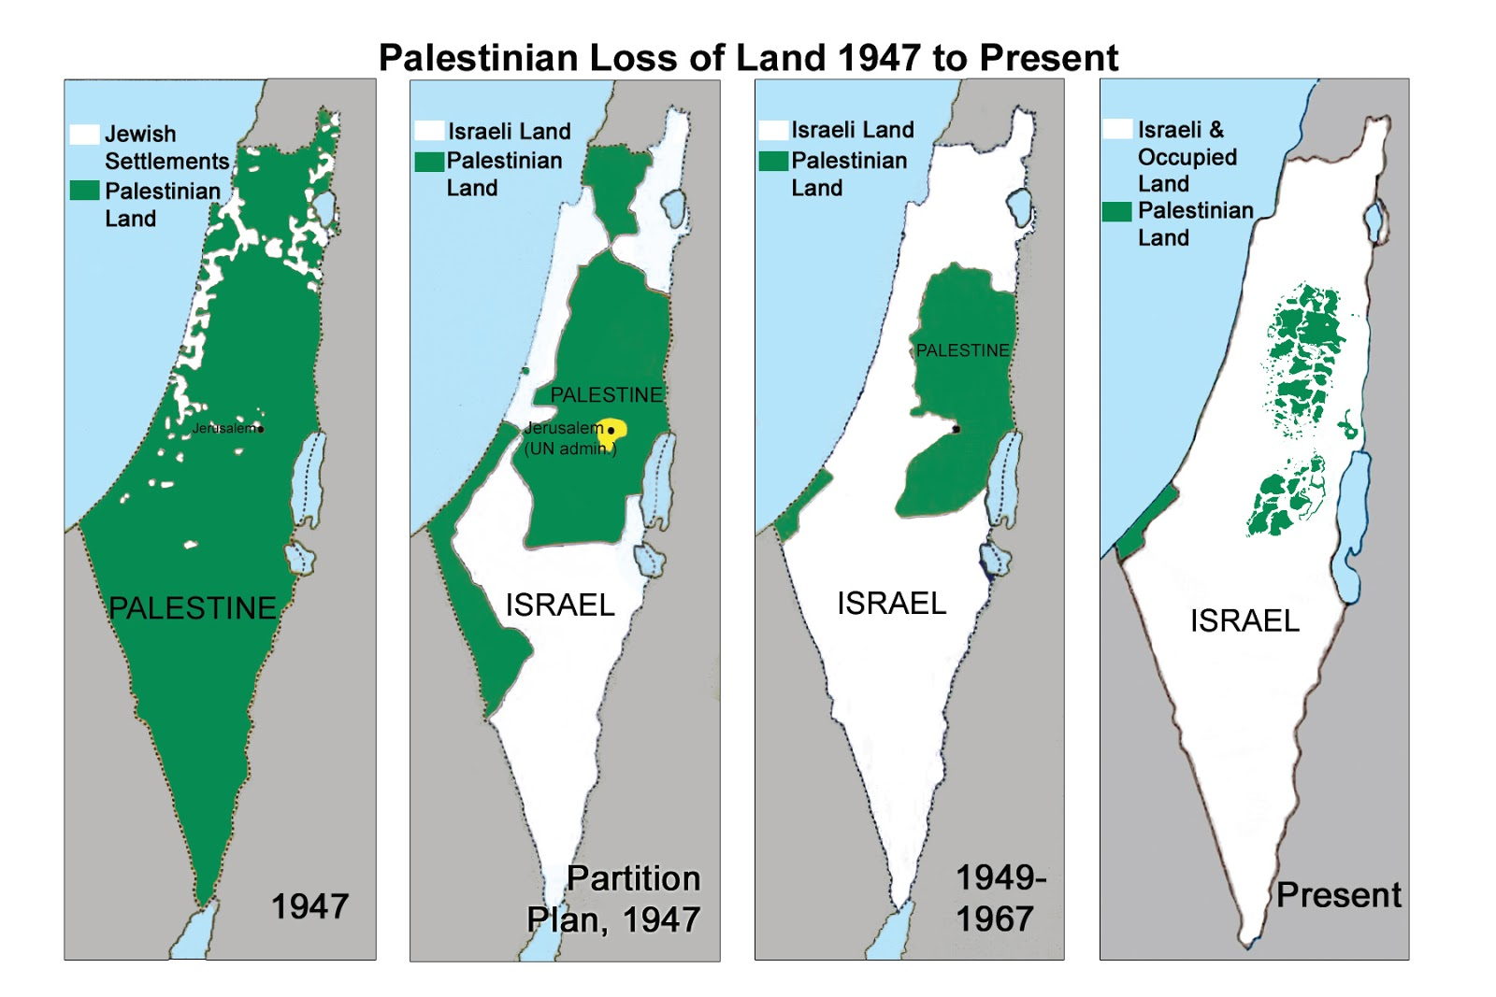

Source J: Questions for Consideration
- How does the title of this map support or refute the idea of a Jewish homeland?

- What can you infer about the Palestinian population from this map?

- Based on the evidence in this map, write two questions you have about the shift in land ownership over the last 65 years.

- How does this information influence your thinking about a Jewish state?

Writing Task

This is an informational writing task based on NVACS standards [WHST 2: 9-10.2a-f]. Students will demonstrate their understanding of the texts as well as the ways in which the textbook was complicated and vivified.

Your parents are going on a Mediterranean Cruise. They will be stopping in Tel Aviv, Israel and driving to Jerusalem for a one-day tour of this historic city. Since they only watch Reality TV and ESPN, they know very little about the Creation of the State of Israel following World War II and nothing about the historical factors contributing to its statehood. They don’t want to appear uninformed on their trip.

Write a one page “White Paper” (see footnote #3) that explains the historical factors that led to the creation of the state of Israel. Write approximately one typed page that includes evidence from at least six of the sources you analyzed. When your quote or paraphrase evidence, be sure to cite the source at the end of the sentence in parentheses like this: Jewish people have held a religious claim to the land of Israel for over 3500 years. They believe that God actually promised this them land for all eternity (Source B).

Action Steps:

- Look at examples of White Papers on line to get a sense of what they look like and their purpose. (Google White Papers and skim through images and some texts)

- Reread Source A- The Textbook. List the main points it makes on a clean sheet of paper. With a partner, refer back to each source. Highlight evidence that will be important to include in your White Paper. Write each piece of evidence down on a strip of paper and include the source letter in parenthesis. You must have at least two pieces of evidence from each source (14 total).

- Organize your evidence. With your partner, move your strips of evidence around to put them in an order that makes sense. How will you organize your white paper; chronologically, with consideration to different nationalities involved in the process, around an idea like historical claims, or geopolitics, Zionism or anti-Semitism? Write a thesis statement that provides an overview of your paper.

- Individually, write your White Paper. Your paper should:
- Articulate support for your thesis in three different ways.
- Use make use of transition words as you guide your audience through the White Paper.
- Use 6-10 content specific vocabulary words to describe the creation of Israel.
- Provide a concluding statement that supports the information you presented.

- Have your partner check your draft to make sure your ideas flow and are correct. They should check to make you are using evidence from the sources and citing sources correctly.

- Finalize your writing and type it using a 12pt font. Be sure to create a title that describes the information you provide in your paper.

- Turn in your White Paper.

“Arab” refers to the diverse ethnic group that inhabits 22 nations throughout Western Asia, North Africa and the Horn of Africa. They are a highly heterogeneous collection of people with diverse cultural practices, religions, and ancestry.
Anti-Semitism: hostility or prejudice against Jews
White Paper: the term for an authoritative report or guide that helps readers understand an issue, solve a problem or make a decision. They are used within government and in business.
Mandate: refers the post-World War I governance of territories under the League of Nations. Great Britain became responsible for the area of Palestine. After the breakup of the League of Nations after WWII, the newly created United Nations was given trusteeship of remaining Mandates; hence its power to determine statehood for nations.
Pogrom: and organized massacre of a particular ethnic group, in particular that of Jews in Russia or Eastern Europe.

