“Peace with Honor” or a Secret War?: Nixon and Vietnam
What was President Nixon doing in Vietnam – Trying to Win or Seeking a Peaceful Resolution?
During the 1968 Presidential campaign, Richard Nixon and Spiro Agnew ran on the Republican ticket. Nixon appealed the “silent majority” – socially conservative Americans that disliked the hippie culture, anti-war activists, and wanted to win the war in Vietnam. In Vietnam, he promised “peace with honor” and campaigned on ending the war and winning peace. Nixon promised to achieve "Peace With Honor." His aim is to negotiate a settlement that will allow the half million U.S. troops in Vietnam to be withdrawn, while still allowing South Vietnam to survive free from Communism. Nixon won the presidential election and was sworn into office in January 1969. The American public waited to see what Nixon would do in Vietnam. Would he escalate the war in order to prevent the spread of communism in South Vietnam or withdraw American forces completely to satisfy American public opinion? Read the following and label the actions with an up arrow if they indicate that President Nixon was escalating the war or with a down arrow if President Nixon appears to be moving towards an honorable peace (be sure to write WHY). Be prepared to discuss your overall conclusion in class tomorrow.

1969
Nixon Begins Secret Bombing of Cambodia: In an effort to destroy Communist supply routes from North Vietnam into South Vietnam that ran through base camps in Cambodia, President Nixon gives the go-ahead to Operation Breakfast. The covert bombing of Cambodia, conducted without the knowledge of Congress or the American public, continues for fourteen months. In spite of government restrictions, President the bombing of North Vietnamese and Vietcong bases within Cambodia. Over the following four years, U.S. forces will drop more than a half million tons of bombs on Cambodia.
Policy of "Vietnamization" Announced: Secretary of Defense Melvin Laird describes the policy of "Vietnamization.” The objective of the policy was to shift the burden of defeating the Communists onto the South Vietnamese Army and away from the United States. The goal was to expand, equip, and train South Vietnam's forces and assign to them an ever-increasing combat role, at the same time steadily reduce the number of U.S. combat troops.
Date | # of Troops  Withdrawn | Date that Withdrawal will be Completed | Monthly  Rate of Withdrawal | Troops Remaining in Vietnam | Troops as a % of January 1969 level
6/8/69 | 25,000 | 8/31/69 | 10,000 | 524,500 | 95%
9/16/69 | 40,500 | 12/15/69 | 11,400 | 484,000 | 88%
12/15/69 | 50,000 | 4/15/70 | 12,500 | 434,000 | 79%

1970
Secretary of States Henry Kissinger and North Vietnamese negotiator Le Duc Tho Begin Secret Peace Talks: The talks were held between North Vietnam and the United States without the presence of South Vietnamese Leader Thieu. Kissinger assured North Vietnam that their troops would be able to remain in the South after the cease-fire. Kissinger also backed down on the U.S. support of the Thieu regime by agreeing to an electoral commission made up of neutralists, Viet Cong and members of the Saigon government that would oversee the political settlement in the South. In return, the North withdrew its condition of Thieu's removal, and agreed the future flow of Vietnamese troops to the South would stop.
Date | Number of Troops  Withdrawn | Date that Withdrawal will be Completed | Monthly  Rate of Withdrawal | Troops Remaining in Vietnam | Troops as a % of January 1969  Level
4/20/1970 | 150,000 | 5/1/1971 | 12,500 | 284,000 | 52%

April President Nixon Orders Invasion of Cambodia: President Nixon orders US and South Vietnamese troops to secretly invade the “Parrot’s Beak” region of Cambodia, thought to be a Viet Cong stronghold. South Vietnamese troops attack into Cambodia: Pushing toward Vietcong bases. Two days later, a U.S. force of 30,000 -- including three U.S. divisions -- mount a second attack. Operations in Cambodia last for 60 days, and uncover vast North Vietnamese jungle supply depots. They capture 28,500 weapons, as well as over 16 million rounds of small arms ammunition, and 14 million pounds of rice. Although most Vietcong manage to escape across the Mekong, there are over 10,000 casualties.
1971
Nixon Announces Plans to Visit China: In a move that troubles the North Vietnamese, President Nixon announces his intention to visit The People's Republic of China. Nixon's gesture toward China is seen by the North Vietnamese as an effort to create discord between themselves and their Chinese allies and force a peace settlement.
Date | Number of Troops  Withdrawn | Date that Withdrawal will be Completed | Monthly  Rate of Withdrawal | Troops Remaining in Vietnam | Troops as a %of January 1969  Level
4/7/1971 | 100,000 | 12/1/1971 | 14,300 | 184,000 | 33%
11/12/1971 | 45,000 | 2/1/1972 | 22,500 | 139,000 | 25%

1972
December 13, 1972: In Paris, the secret peace talks between the North Vietnamese and the Americans breakdown. By October 1972, a tentative cease-fire agreement was reached. The accord called for the simultaneous withdrawal of U.S. troops and freedom for American POWs, to be followed by a political settlement of South Vietnam's future. Washington would extend postwar economic assistance to help Vietnam rebuild its destroyed infrastructure. On October 22, Nixon suspended all bombing north of the twentieth parallel and four days later Kissinger proclaimed that "peace was at hand." The celebration was premature because South Vietnamese leader Thieu, had not been consulted during the secret negotiations. He now demanded changes that infuriated North Vietnam, and talks broke off on December 13. Nixon, caught between a stubborn ally and a tough enemy, took action. He promised Thieu $1 billion in military equipment that would give South Vietnam the fourth largest air force in the world and assured Thieu that the United States would re-enter the war if North Vietnam did not abide by the peace.
December 18, 1972: In an attempt to force North Vietnam to make concessions in the ongoing peace talks, the Nixon administration orders heavy bombing of supply dumps and petroleum storage sites in and around Hanoi and Haiphong. The administration makes it clear to the North Vietnamese that no section of Vietnam is off-limits to bombing raids. By order of the president, a new bombing campaign starts against the North Vietnamese. Operation Linebacker Two lasts for 12 days, including a three day bombing period by up to 120 B-52s. Strategic surgical strikes are planned on fighter airfields, transport targets and supply depots in and around Hanoi and Haiphong. U.S. aircraft drop more than 20,000 tons of bombs in this operation. Twenty-six U.S. planes are lost, and 93 airmen are killed, captured or missing. North Vietnam admits to between 1,300 and 1,600 dead. During 12 days of the most concentrated bombing in world history, called the Christmas bombing, American planes flew nearly 2,000 sorties and dropped 35,000 tons of bombs against transportation terminals, rail yards, warehouses, barracks, oil tanks, factories, airfields and power plants in the North. In two short weeks, 25 percent of North Vietnam's oil reserves and 80 percent of its electrical capacity were destroyed. The U.S. lost 26 aircraft and 93 air force men.
Date | Number of Troops  Withdrawn | Date that Withdrawal will be Completed | Monthly  Rate of Withdrawal | Troops Remaining in Vietnam | Troops as a %of January 1969  Level
1/13/1972 | 70,000 | 5/1/1972 | 23,300 | 69,000 | 13%
4/26/1972 | 20,000 | 7/1/1972 | 10,000 | 49,000 | 9%
6/28/1972 | 10,000 | 9/1/1972 | 5,000 | 39,000 | 7%
8/29/1972 | 12,000 | 12/1/1972 | 4,000 | 27,000 | 5%

“Peace with Honor” or a Secret War?: Nixon and Vietnam
By April of 1970, 77% of Americans polled approved of how Nixon was handling the situation in Vietnam and only 6% disapproved. Nixon's overall approval rating climbed from 56% to 67%. . Although Nixon had increased his personal support, other indicators suggested that the public remained divided on policy in Vietnam. 55% of public now classified themselves as "doves" with only 31% using the "hawk" label. In April 1970, President Nixon in a televised speech to the American public defended his decision to send U.S. troops into Cambodia, an action that would widen the war. The President spoke at 9 p.m. in his office at the White House. His address was broadcast live on radio and television.
Source 2: Address to the Nation on the Situation in Southeast Asia, President Nixon, April 30, 1970

Good evening my fellow Americans:
Ten days ago, in my report to the Nation on Vietnam, I announced a decision to withdraw an additional 150,000 Americans from Vietnam over the next year. I said then that I was making that decision despite our concern over increased enemy activity in Laos, in Cambodia, and in South Vietnam.
At that time, I warned that if I concluded that increased enemy activity in any of these areas endangered the lives of Americans remaining in Vietnam, I would not hesitate to take strong and effective measures to deal with that situation.
Despite that warning, North Vietnam has increased its military aggression in all these areas, and particularly in Cambodia.
After full consultation with the National Security Council…and my other advisers, I have concluded that the actions of the enemy in the last 10 days clearly endanger the lives of Americans who are in Vietnam now and would constitute an unacceptable risk to those who will be there after withdrawal of another 150,000.
To protect our men who are in Vietnam and to guarantee the continued success of our withdrawal and Vietnamization programs, I have concluded that the time has come for action.
...For the past 5 years - as indicated on this map that you see here - North Vietnam has occupied military sanctuaries all along the Cambodian frontier with South Vietnam. Some of these extend up to 20 miles into Cambodia. The sanctuaries are in red and, as you note, they are on both sides of the border. They are used for hit and run attacks on American and South Vietnamese forces in South Vietnam.
These Communist occupied territories contain major base camps, training sites, logistics facilities, weapons and ammunition factories, airstrips, and prisoner-of-war compounds.
...In cooperation with the armed forces of South Vietnam, attacks are being launched this week to clean out major enemy sanctuaries on the Cambodian-Vietnam border.
...This is not an invasion of Cambodia. The areas in which these attacks will be launched are completely occupied and controlled by North Vietnamese forces. Our purpose is not to occupy the areas. Once enemy forces are driven out of these sanctuaries and once their military supplies are destroyed, we will withdraw.
...Now let me give you the reasons for my decision.
A majority of the American people, a majority of you listening to me, are for the withdrawal of our forces from Vietnam. The action I have taken tonight is indispensable for the continuing success of that withdrawal program.
A majority of the American people want to end this war rather than to have it drag on interminably. The action I have taken tonight will serve that purpose.
A majority of the American people want to keep the casualties of our brave men in Vietnam at an absolute minimum. The action I take tonight is essential if we are to accomplish that goal.
We take this action not for the purpose of expanding the war into Cambodia but for the purpose of ending the war in Vietnam and winning the just peace we all desire. We have made - we will continue to make every possible effort to end this war through negotiation at the conference table rather than through more fighting on the battlefield.
Let us look again at the record. We have stopped the bombing of North Vietnam. We have cut air operations by over 20 percent. We have announced withdrawal of over 250,000 of our men. We have offered to withdraw all of our men if they will withdraw theirs. We have offered to negotiate all issues with only one condition - and that is that the future of South Vietnam he determined not by North Vietnam, and not by the United States, but by the people of South Vietnam themselves…
...The action that I have announced tonight puts the leaders of North Vietnam on notice that we will he patient in working for peace; we will be conciliatory at the conference table, but we will not be humiliated. We will not be defeated. We will not allow American men by the thousands to be killed by an enemy from privileged sanctuaries.
The time came long ago to end this war through peaceful negotiations. We stand ready for those negotiations. We have made major efforts, many of which must remain secret. I say tonight: All the offers and approaches made previously remain on the conference table whenever Hanoi is ready to negotiate seriously.
But if the enemy response to our most conciliatory offers for peaceful negotiation continues to be to increase its attacks and humiliate and defeat us, we shall react accordingly.
If, when the chips are down, the world's most powerful nation, the United States of America, acts like a pitiful, helpless giant, the forces of totalitarianism and anarchy will threaten free nations and free institutions throughout the world.
During my campaign for the Presidency, I pledged to bring Americans home from Vietnam. They are coming home.
I promised to end this war. I shall keep that promise.
I promised to win a just peace. I shall keep that promise.
We shall avoid a wider war. But we are also determined to put an end to this war.
...Thank you and good night.
“Peace with Honor” or a Secret War?: Nixon and Vietnam
Time Magazine was one of the most circulated magazines in the 1960s. Although initially a supporter of the Vietnam War, in 1968 the magazine’s managing editor wrote an editorial conceding that the war was unwinnable.
Source 3: “Will Nixon’s Gamble Work?” Times, May 1970

Richard Nixon took office in 1969, promising to end the war with Vietnam quickly. He pledged "peace with honor." But after more than three years, the United States was still mired in the conflict. Nixon had thought he could convince the Soviet Union to nudge communist North Vietnam into a peace agreement, but he soon concluded that diplomacy alone wouldn't get him out of the war. He also knew the American public would no longer tolerate the deaths of 1,000 GIs each month.
Over the next three years, the president took a two-track approach: he brought home troops by the tens of thousands, announcing to the nation another withdrawal every few months. At the same time, he ordered intense bombing campaigns over North Vietnam and covert attacks and incursions into neighboring Cambodia and Laos, which he often tried to hide from the American public.
Richard Nixon and his national security advisor, Henry Kissinger, knew they could not win the war, says Historian Mel Small, author of The Presidency of Richard Nixon. But they hoped strategic military escalation would help the US gain concessions from the North Vietnamese -- and shore up the South Vietnamese -- as the United States pulled out of the war. Their "Vietnamization" plan also included giving South Vietnam on-going political direction and economic aid so that the South eventually could fend off the North on its own.
By spring of 1972, a half-million American troops had come home. There were about 60,000 left when North Vietnam unleashed a massive assault on South Vietnam on March 30 of that year. The attack infuriated Nixon, who felt the North Vietnamese were taking advantage of the troop withdrawal just as the war was supposed to be winding down. This time, Nixon decided to go on the counter-offensive. He chose a military tactic that both he and President Lyndon Johnson had contemplated over the course of the war: mining North Vietnam's harbors to block war supplies being shipped from the Soviet Union and other Eastern Bloc countries. Mining was always considered a dangerous escalation of the war. Because the ships most likely to get blown up belonged to the Soviets, a mine explosion could trigger a direct confrontation with them.
Most of Nixon's advisors opposed mining because they believed it would jeopardize the president's plans for a peace-making summit in Moscow, scheduled to occur just two weeks after the mines were dropped into sea by American war planes. But Nixon was determined to punish the North Vietnamese and willing to take his chances with the U.S.S.R.. He knew the Soviets were eager to solidify a policy of detente with the United States, especially after Nixon opened relations with communist China - a Soviet enemy - in early 1972. Nixon wagered that the Soviet Union would complain about the mining, but stick with the summit.
On Monday night, May 8, 1972, Nixon met first with Congressional leaders, and then went on national television, to explain his decision to mine the Hanoi and Haiphong harbors and intensify bombing over North Vietnam. He also reiterated U.S. terms for a peace agreement. Privately, he was determined to bring North Vietnam to its knees. Nixon wrote in a memo later that evening: "I cannot emphasize too strongly that I have determined that we should go for broke…Needless to say, indiscriminate bombing of civilian areas is not what I have in mind. On the other hand, if the target is important enough, I will approve a plan that goes after it even if there is a risk of some civilian casualties. We have the power. The only question is whether we have the will to use that power. What distinguishes me from Johnson is that I have the will in spades…"

Even before Nixon spoke, a Harris poll indicated that 59% of the nation opposed committing U.S. troops, advisers or bombing missions in either Laos or Cambodia. An informal poll by the Detroit Free Press found 75% against any Cambodian venture.
According to the White House switchboard, calls ran 6 to 1 in the President's favor. Senate Republican Leader Hugh Scott, who cheerlessly supported the President, took a different reading. Telegrams to his office were 20 to 1 against the Cambodian expedition. Even in the Midwest, where support for both the Johnson and Nixon war policies has been relatively strong, the Silent Majority loyalty may prove thin. TIME correspondents around the nation found little enthusiasm for the President's new policy, even among those Americans who feel that the war must be continued until it is won. Even the hawks were muted. At best there was a trust that Nixon must know what he is doing. At worst, there was the feeling summed up in the bitter comment of a NASA official in Houston: "I guess Nixon wanted his own war.” …Said Republican Senator Robert Dole, a party loyalist who also keeps a well-trained eye on sentiment back home in Kansas: "If it works, it's a stroke of genius. If it doesn't, he strikes out.”
“Peace with Honor” or a Secret War?: Nixon and Vietnam

Source #5: Political Cartoons
Cartoonist Herb Block, a longtime Washington Post fixture and dedicated political opponent of Nixon since 1950.

“Now, As I was saying four years ago!”
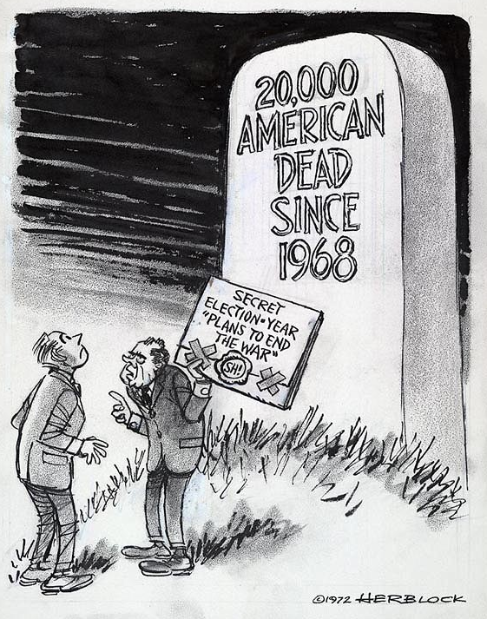

Fourth Year Of the “Plan To End The War” (Contd.)
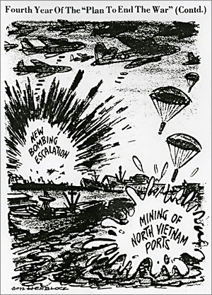

“Peace with Honor” or a Secret War?: Nixon and Vietnam
What was President Nixon doing in Vietnam – Trying to Win or Seeking a Peaceful Resolution?

Source |  | Win the War | Peaceful End
Source 1: President Nixon's Address to the Nation on the War in Vietnam  "The Silent Majority" Speech, November 3, 1969 | Worried about the influence of anti-war groups, President Nixon instituted a program of investigation and harassment, and speeches to make this point. Vice President Spiro Agnew Speaking at a dinner in Jackson, Mississippi on October 20th, asserting that liberals possessed a "masochistic compulsion to destroy their country's strength." The leaders of the Vietnam Mobilization were described as "hard-core dissidents and professional anarchists." To further his attack on the anti-war movement at 9:30 PM on November 3, 1969, President Nixon addressed a national television audience from the White House. This speech was designed to buy time in Vietnam and to reach out to dissident Democrats along with Nixon's core constituency. The public reaction to the president's speech was most favorable. Among those who watched the address, 77% approved of how Nixon was handling the situation in Vietnam and only 6% disapproved. In the wake of the speech, Nixon's overall approval rating climbed from 56% to 67%. Although Nixon had increased his personal support, other indicators suggested that the public remained divided on policy in Vietnam. 55% of public now classified themselves as "doves" with only 31% using the "hawk" label
Source 2: Address to the Nation on the Situation in Southeast Asia, President Nixon, April 30, 1970 | By April of 1970, 77% of Americans polled approved of how Nixon was handling the situation in Vietnam and only 6% disapproved. Nixon's overall approval rating climbed from 56% to 67%. Although Nixon increased his personal support, other indicators suggested that the public remained divided on policy in Vietnam. 55% of public now classified themselves as "doves" with only 31% using the "hawk" label. In April 1970, President Nixon in a televised speech to the American public defended his decision to send U.S. troops into Cambodia, an action that would widen the war. The President spoke at 9 p.m. in his office at the White House. His address was broadcast live on radio and television.
Source 3:. “Will Nixon’s Gamble Work?” Times, May 1970 | One of the most circulated magazines in the 1960s. Though a socially conservative, Time focused attention on the counter-culture and the political and intellectual radicalism of the 1960s. Although initially a supporter of the Vietnam War, in 1968 the magazine’s managing editor wrote an editorial conceding that the war was unwinnable.
Source 4: Mobe Advertisement in the Washington Post, May 1, 1970 | The National Mobilization Committee to End the War in Vietnam (Mobe) was formed in 1967. Mobe planned a large demonstration for Washington D.C. on October 21, 1967. This demonstration was a march to the Pentagon, where another rally would be held in a parking lot, followed by civil disobedience on the steps of the Pentagon itself. The action was known as the "March on the Pentagon." The initial rally drew some 100,000 people with about 35,000 marching and participating in the second rally at the Pentagon. About 800 people were arrested for civil disobedience on the steps of the Pentagon. This advertisement was placed in the Washington Post after the public announcement of the expansion of the war into Cambodia
Source 5: Political Cartoons  A. Now, As I was saying four years ago!  B. Fourth Year Of the “Plan To End The War” | Cartoonist Herb Block, a longtime Washington Post fixture and dedicated political opponent of Nixon since 1950.
Source 6: Taped White House Conversations and Memos | President Nixon, just like the five presidents before him, taped all of the conversations that occurred in the Oval Office and over the telephone. The following are transcriptions of telephone conversations and memos between President Nixon and his Secretary of State Henry Kissinger.

“Peace with Honor” or a Secret War?: Nixon and Vietnam
What was President Nixon doing in Vietnam – Trying to Win or Seeking a Peaceful Resolution?
The National Mobilization Committee to End the War in Vietnam (Mobe) was formed in 1967. Mobe planned a large demonstration for Washington D.C. on October 21, 1967. This demonstration was a rally at West Potomac Park near the Lincoln Memorial and a march to the Pentagon, where another rally would be held in a parking lot, followed by civil disobedience on the steps of the Pentagon itself. The action was known as the "March on the Pentagon." The initial rally drew some 100,000 people with about 35,000 marching and participating in the second rally at the Pentagon. About 800 people were arrested for civil disobedience on the steps of the Pentagon. Following the Pentagon demonstration, the Mobe began discussion and planning for demonstrations at the 1968 Democratic National Convention, to be held in Chicago, where President Lyndon B. Johnson was expected to be nominated for a second term. This advertisement was placed in the Washington Post after the public announcement of the expansion of the war into Cambodia
Source 4: Mobe Advertisement in the Washington Post, May 1, 1970
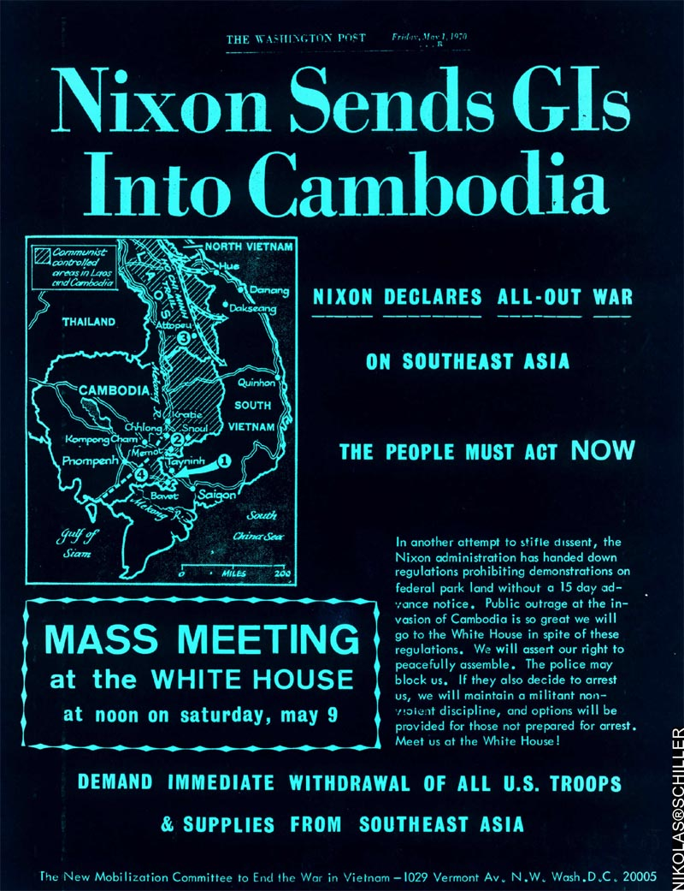
“Peace with Honor” or a Secret War?: Nixon and Vietnam

President Nixon, just like the five presidents before him, taped all of the conversations that occurred in the Oval Office and over the telephone. The following are transcriptions of telephone conversations and Top-Secret memos between President Nixon and his Secretary of State Henry Kissinger.
Source 6: Taped Conversations and Top Secret Memos Between President Richard Nixon and Secretary of State Henry Kissinger
September 10, 1969: Top Secret memo from Secretary of State Henry Kissinger to President Nixon
“…I do not believe that with our current plans we can win the war within two years…Withdrawal of U.S. troops will become like salted peanuts to the American public: The more U.S. troops come home, the more will be demanded. This could result, in effect, in demands for unilateral withdrawal—perhaps within a year. The more troops are withdrawn, the more Hanoi [North Vietnam] will be encouraged—they are the last people we will be able to fool about the ability of the South Vietnamese to take over for us…There is not therefore enough of a prospect of progress in Vietnam to persuade Hanoi [North Vietnam] to make real concessions in Paris [Paris peace talks between the United States and North Vietnam]. Their intransigence is based on their estimate of growing U.S. domestic opposition to our Vietnam policies. It looks like they are prepared to wait us out.”
December 9, 1970 8:45 PM: Taped conversation between President Nixon and Secretary of State Henry Kissinger. All of the words are from President Nixon
…They [the United States Air Force] have got to go in there [Cambodia] and I mean really go in. I don’t want gunships, I want helicopter ships. I want everything that can fly to go in there and crack the hell out of them. There is no limitation on mileage and there is no limitation on budget. Is that clear?
…We are airlifting supplies [into Cambodia] and sure there are some troops but I don’t want numbers out [to the public or the press]. I don’t want anything like that. I don’t want the plan out and I don’t want the air force bragging about it and I don’t want a goddamn thing said [to the public or the press].
…I want them [the United States Air Force] to hit everything. I want them to use the big planes, the small planes, everything they can that will help out there [in Cambodia] and lets start giving them [the North Vietnamese] a little shock.
…We have got to do a better job because we are just coming to the crunch. Right now there is a chance to win this goddamn war and that’s probably what we are going to have to do because we are not going to do anything at the conference table [during peace negotiations with North Vietnam]…
May 1972: In three top-secret eyes-only memos to Mr. Kissinger, President Nixon explains his thinking behind escalating the bombing and mining of North Vietnam's harbors.
May 9: You have often mentioned the necessity of creating the impression in the enemy's mind that I am absolutely determined to end the war and will take whatever steps are necessary to accomplish this goal. The time to take those steps is now. . . . I cannot emphasize too strongly that I have determined that we should go for broke. . . . Our greatest failure would be to do too little too late. [Called the madman scenario, it was devised for negotiating with the government of North Vietnam. In this gambit, Henry Kissinger would emphasize, in his meetings with representatives of North Vietnam, the volatility of President Nixon's personality. He would warn the North Vietnamese that Nixon was unpredictable, that he could fly into a rage, and that this could happen in response to either North Vietnamese military action or intransigence in the peace talks. A similar theme was sounded by Kissinger in his dealing with the American press.]
May 10: On an urgent basis, I want the C.I.A. to implement . . . broadcasts, leaflets and every other device so that the North Vietnamese . . . are told of the massive public support for the president's decision . . . and any other story that might discourage the North Vietnamese leaders [from continuing to fight rather than negotiating a peace].

“Peace with Honor” or a Secret War?: Nixon and Vietnam
Worried about the influence of anti-war groups, President Nixon instituted a program of investigation and harassment, and speeches to make this point. Vice President Spiro Agnew Speaking at a dinner in Jackson, Mississippi on October 20th, asserting that liberals possessed a "masochistic compulsion to destroy their country's strength." The leaders of the Vietnam Mobilization were described as "hard-core dissidents and professional anarchists." To further his attack on the anti-war movement at 9:30 PM on November 3, 1969, President Nixon addressed a national television audience from the White House. This speech was designed to buy time in Vietnam and to reach out to dissident Democrats along with Nixon's core constituency. The public reaction to the president's speech was most favorable. Among those who watched the address, 77% approved of how Nixon was handling the situation in Vietnam and only 6% disapproved. In the wake of the speech, Nixon's overall approval rating climbed from 56% to 67%. Although Nixon had increased his personal support, other indicators suggested that the public remained divided on policy in Vietnam. 55% of public now classified themselves as "doves" with only 31% using the "hawk" label
Source 1: Nixon's Address to the Nation on the War in Vietnam
"The Silent Majority" Speech, November 3, 1969

Good evening, my fellow Americans:
Tonight I want to talk to you on a subject of deep concern to all Americans and to many people in all parts of the world--the war in Vietnam.
I believe that one of the reasons for the deep division about Vietnam is that many Americans have lost confidence in what their Government has told them about our policy. The American people cannot and should not be asked to support a policy which involves the overriding issues of war and peace unless they know the truth about that policy.
Tonight, therefore, I would like to answer some of the questions that I know are on the minds of many of you listening to me.
How and why did America get involved in Vietnam in the first place? How has this administration changed the policy of the previous administration? What has really happened in the negotiations in Paris and on the battlefront in Vietnam? What choices do we have if we are to end the war? What are the prospects for peace?
Now, let me begin by describing the situation I found when I was inaugurated on January 20.
--The war had been going on for 4 years.
--31,000 Americans had been killed in action.
--The training program for the South Vietnamese was behind schedule.
--540,000 Americans were in Vietnam with no plans to reduce the number.
--No progress had been made at the negotiations in Paris and the United States had not put forth a comprehensive peace proposal.
--The war was causing deep division at home and criticism from many of our friends as well as our enemies abroad.
In view of these circumstances there were some who urged that I end the war at once by ordering the immediate withdrawal of all American forces.
…But the question facing us today is: Now that we are in the war, what is the best way to end it?
In January I could only conclude that the precipitate withdrawal of American forces from Vietnam would be a disaster not only for South Vietnam but for the United States and for the cause of peace.
For the United States, this first defeat in our Nation's history would result in a collapse of confidence in American leadership, not only in Asia but throughout the world.
Three American Presidents have recognized the great stakes involved in Vietnam and understood what had to be done…For the future of peace, precipitate withdrawal would thus be a disaster of immense magnitude.
Ultimately, this would cost more lives. It would not bring peace; it would bring more war.
For these reasons, I rejected the recommendation that I should end the war by immediately withdrawing all of our forces. I chose instead to change American policy on both the negotiating front and battlefront. In order to end a war fought on many fronts, I initiated a pursuit for peace on many fronts…
--We have offered the complete withdrawal of all outside forces within 1 year.
--We have proposed a cease-fire under international supervision.
--We have offered free elections under international supervision with the Communists participating in the organization and conduct of the elections as an organized political force….
…In the previous administration, we Americanized the war in Vietnam. In this administration, we are Vietnamizing the search for peace….
The Vietnamization plan was launched…in March. Under the plan, I ordered first a substantial increase in the training and equipment of South Vietnamese forces…the primary mission of our troops is to enable the South Vietnamese forces to assume the full responsibility for the security of South Vietnam.
Let me now turn to our program for the future.
We have adopted a plan which we have worked out in cooperation with the South Vietnamese for the complete withdrawal of all U.S. combat ground forces, and their replacement by South Vietnamese forces on an orderly scheduled timetable. This withdrawal will be made from strength and not from weakness. As South Vietnamese forces become stronger, the rate of American withdrawal can become greater.
…And so tonight-to you, the great silent majority of my fellow Americans-I ask for your support.
I pledged in my campaign for the Presidency to end the war in a way that we could win the peace. I have initiated a plan of action which will enable me to keep that pledge.
The more support I can have from the American people, the sooner that pledge can be redeemed; for the more divided we are at home, the less likey, the enemy is to negotiate at Paris.
Let us be united for peace. Let us also be united against defeat. Because let us understand: North Vietnam cannot defeat or humiliate the United States. Only Americans can do that…
I pledge to you tonight that I shall meet this responsibility with all of the strength and wisdom I can command in accordance with your hopes, mindful of your concerns, sustained by your prayers.
Thank you and goodnigh

