Resource 1
Resource #1
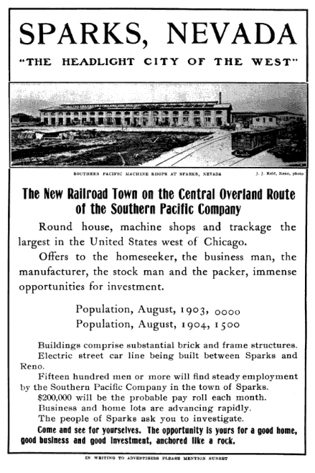
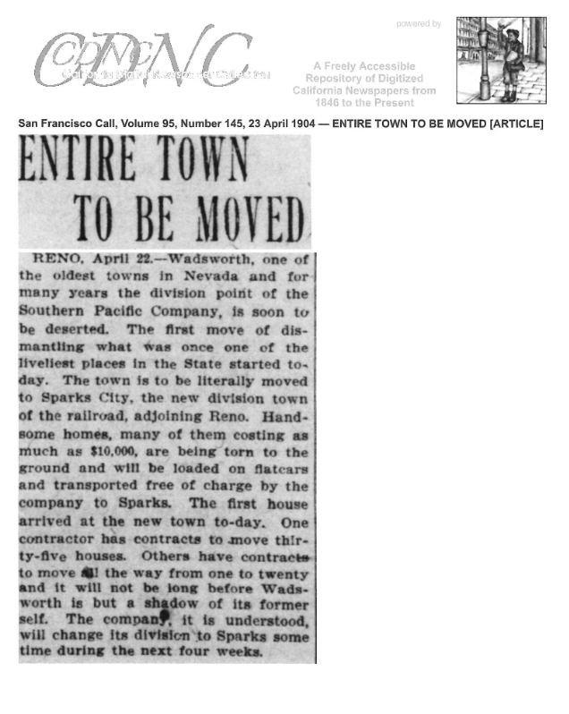
Resource 2A
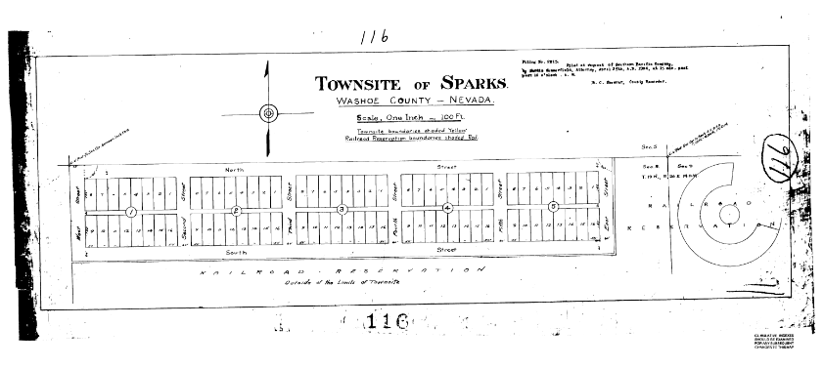
Resource 3
The Railroad Reserve is show in map 116 (dated April 25, 1904). All of the deeds for lots in the Reserve followed this map. The lots were 50 feet by 140 feet.
Source: The Washoe County Recorder’s office

Before the big move in July 1904, the Southern Pacific Company had 64 lots set aside for employees who owned property in Wadsworth. For one dollar, the owner had his name placed in a lottery for the lots. In the summer of 1903, the names and lot numbers were placed in separate hats. Miss Gladys Pratt, the daughter of the Southern Pacific’s master mechanic, pulled the name out of one hat and then a lot number from the other. There were three more names left in the hat after all the lots were drawn. The Southern Pacific Company than gave those employees three lots on Harriman must east of the 64 drawn lots. The entire area became known as the Reserve since all the deeds forbid the property to be occupied by any business establishment or saloon. Another requirement was that the employee had 90 days to build his house after filing the deed with Washoe County. William R. Brown was the first employee to file his deed with Washoe County.
The lots were first laid out east and west. After much discussion they were resurveyed to lay north and south. These lots were 40 feet by 140 feet while the rest of the city lots were 25 feet by 142.5 feet.
The Southern Pacific Company assisted the move by providing transportation for the buildings and household goods. Houses were dismantled and placed on flat cars; household goods were shipped in box cars or by wagon along with shrubs and trees. Only the grass remained at Wadsworth.
When the Southern Pacific Company converted to diesel locomotives in 1956, it withdrew the shops from Sparks. The clause in the deeds pertaining to the business restriction became void. All of the homes that were in “The Reserve” have been displaced either by Interstate 80 or the Nugget.
Source: Excerpted from: History of Sparks, Centennial Edition

Resource 4A
Original Map of Sparks

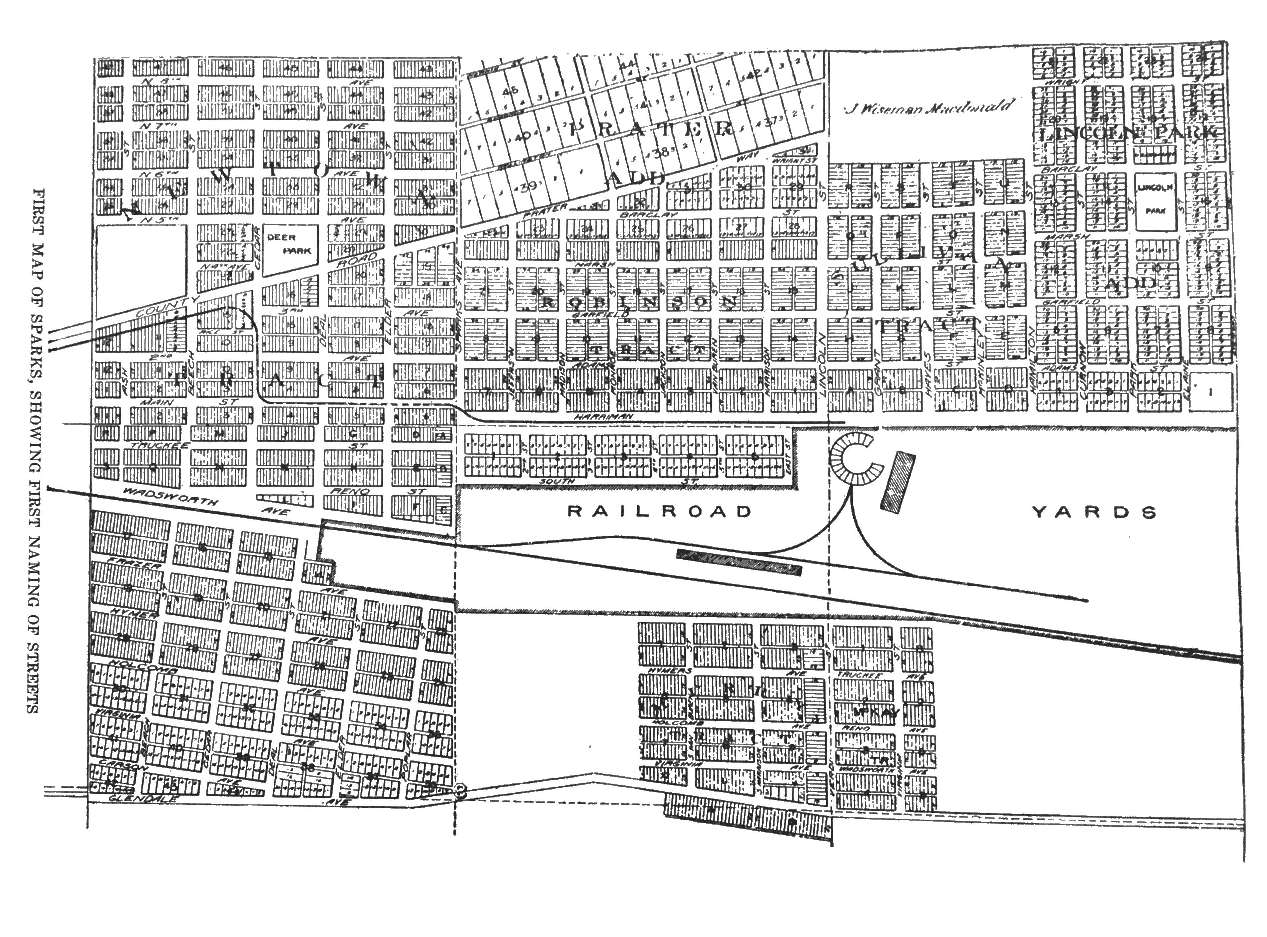

Resource 4B
